**Export Control eRouting Module Submission and Review Procedures**

**For Chip Fabrication**

This user guide provides instructions for submitting an export review request for the production or manufacturing of chips or wafers. An export review is required if any of the following apply:

* chip or wafer will be produced outside the USA
* chip or wafer will be sent outside the USA for post-production processing
* when design will be sent to a third part for processing
* when required by foundry

To ensure your request is processed in a timely manner, we ask that you follow the steps below. The index below is linked so you can skip the appropriate section as needed.

**INDEX:**

1. Device ID Naming
2. Completing the Chip/Device Fabrication Export Questionnaire
3. Submitting the Export Questionnaire via the Export Control Module in eRouting
4. Checking the Status via the Export Control Module in eRouting
5. Glossary

**1)** **Device ID Naming:**

Each Tapeout is submitted with a multi-part device name which provides key details to the foundry where the chip will be produced as well as the PD/PI responsible the chip. The Device name submitted to foundry should match exactly what is submitted for export review. Submissions with different names are likely to be rejected or delayed. For example, in the following Device ID, MPW4R05_Burdell_2D_Blue_062920, the Yellow part of the name was created by the Foundry and the Green part of the name was created by the PD/PI (Dr. George P. Burdell). Below is the key for each part and how the Georgia Tech PD/PI should name the Device ID.

MPW4R05 (named by Foundry)

MPW = Multi Project Wafer (defines the type of wafer)

4R = defines the platform

05 = defines that this is the 5th run of this type for the year

Burdell_2D_Blue_062920 (named by GT PD/PI)

Burdell = defines the PD/PI name

2D = defines the number of Designs on this Device ID (2 is the #, D stands for design(s))

Blue = unique name selected by PD/PI (can use lab pattern such name of plane, color, etc.)

062920 = defines the expected date of the tapeout as 06/29/2020

When naming your Device ID for submission to an external foundry, please be sure to use the above format.

**The Device name submitted to foundry should match exactly what is submitted for export review.**

Example of Device ID name submitted to Foundry:

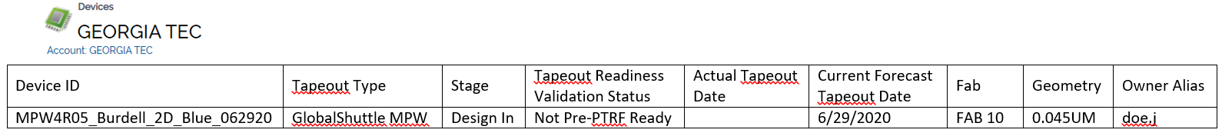

Example of GT Export Questionnaire form submitted in the GT eRouting Export System:

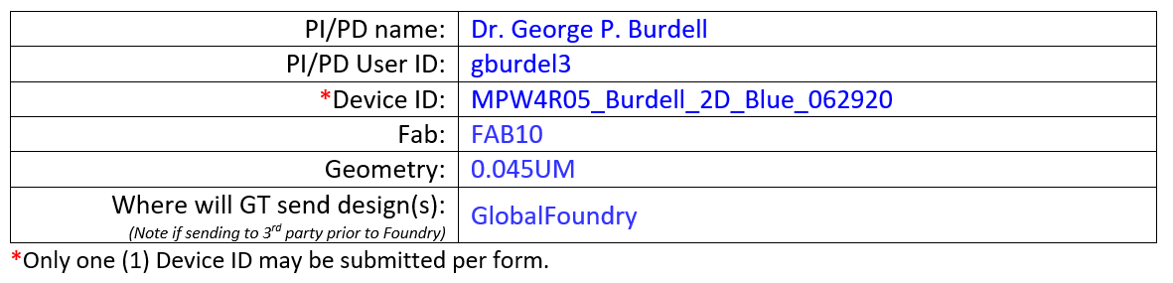

*Return to Index*

**2)** **Completing the Chip/Device Fabrication Export Questionnaire**

Lab personnel (Graduate Student, Post-Doc, Lab Associate, etc.) may assist in completing the initial questionnaire but the PD/PI is ultimately responsible for ensuring all information provided is correct.

Download a new copy of the form each time (or check the date in the footer) to ensure you are using the most recent version of the form as it is updated as regulatory requirements change and as we work to streamline the process for PD/PIs. The Office of Research Integrity Assurance (ORIA) and Export Compliance Coordinators (ECC) will complete the export review and facilitate the export approval for device submission.

The questionnaire can be found on the export website at:  [Chip/Device Fabrication Export Questionnaire](https://researchintegrity.gatech.edu/sites/default/files/documents/export_questionnaire_for_chip_design_manufacturing.docx)

Once you have completed the above document, save the file to your computer. The document can be submitted via the Export Control Module in eRouting (*see* *submitting export questionnaire* *within this document for details*) for review and approval.

**The Device name submitted to foundry should match exactly what is submitted for export review (***see* *Device ID Naming* *within this document for details***).**

**Each Design** should have a separate Device ID for submission to the Foundry and export review and foundry submission.

A sample form is available on the [Export Forms webpage](https://researchintegrity.gatech.edu/export-control/forms-and-procedures) for your convenience.

*Return to Index*

**3)** **Submitting the Export Questionnaire via the Export Control Module in eRouting:**

To facilitate routing and documentation of Chip Manufacturing Export Reviews, all request should be submitted via the Export Control Module in [eRouting](https://erouting.gatech.edu/erouting.). This system will allow the PD/PI to track the approval process and answer any questions about the Device or Designs.

After completing the [Export Questionnaire for Chip Design Manufacturing](https://researchintegrity.gatech.edu/sites/default/files/documents/export_questionnaire_for_chip_design_manufacturing.docx) form (*see* *Completing Export Questionnaire* *within this document for details*), login to [eRouting](https://erouting.gatech.edu/erouting.) and use the “Create a new Non-Sponsored Export Review” link to submit.

(Note: even if your design is under a Sponsored Research Agreement, use the Non-Sponsored link as most submissions have more than one funding source. The Export office will connect the review to the appropriate funding activities you list in the questionnaire.)

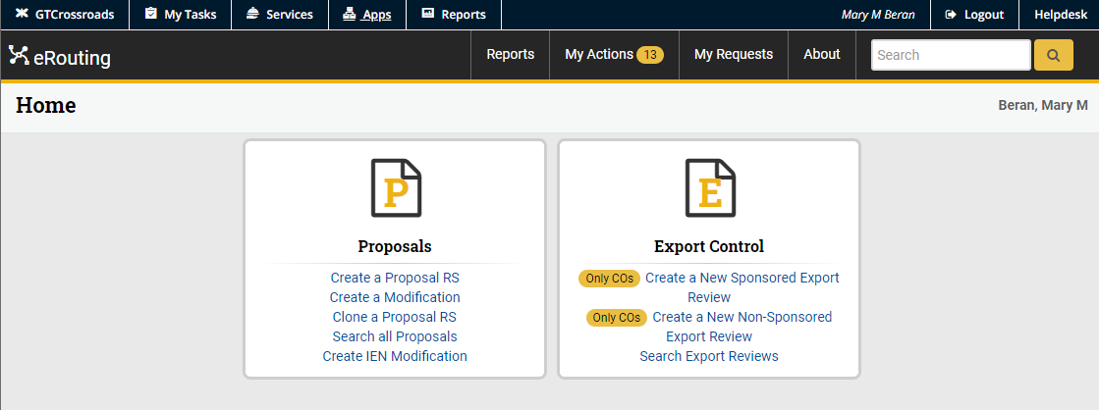

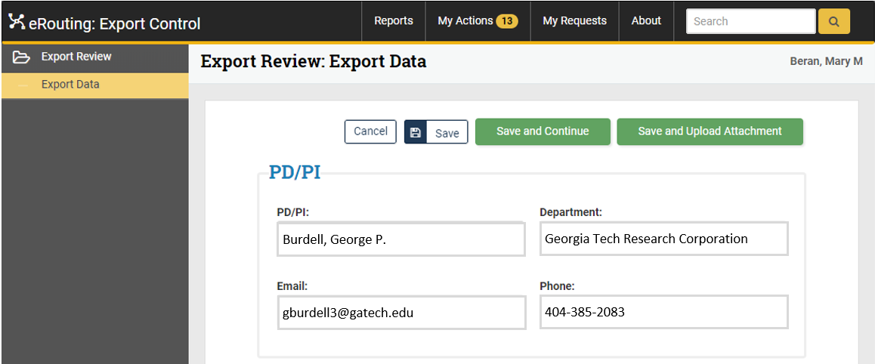

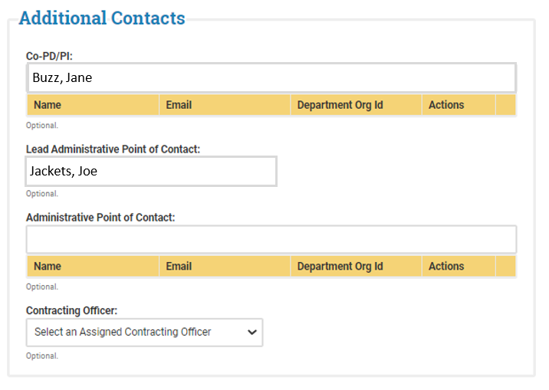

CO-PD/PI (Optional):

If you have a CO-PI select the individual using the drop down list.

Administrative Contacts (Optional):

You can list a student or other contact who will assist with the review here.

Contracting Officer:

Leave blank

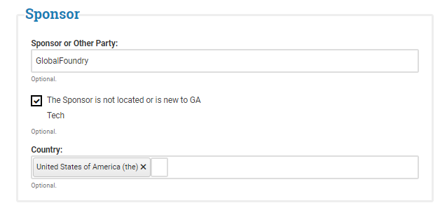

Sponsor:

Add Foundry name

(note: if submission is to GF – there is no space in the name (see left))

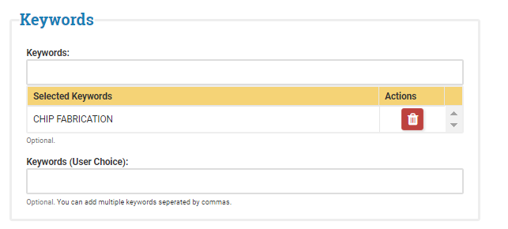

Keywords (optional):

Add “Chip Fabrication” or any other keywords you would like.

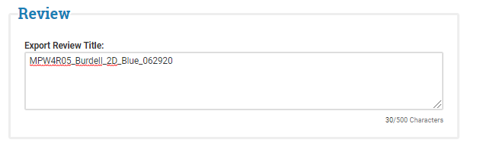**Export Review Title (REQUIRED):**

The Title should match exactly what is submitted on both the Export Questionnaire & the Device ID submitted to the Foundry (*see* *Device ID Naming* *within this document for details*).

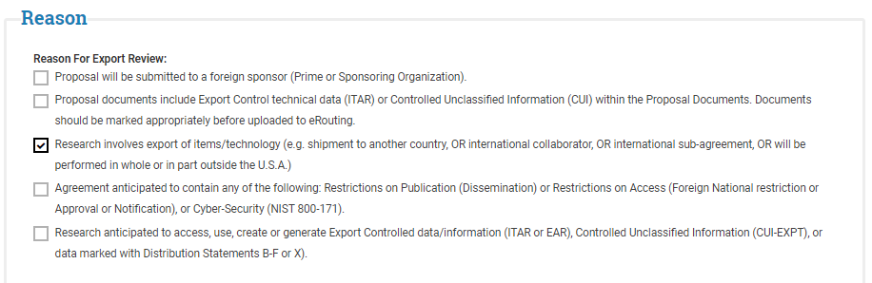Reason (REQUIRED):

All chip review request should check the 3rd box and may check others as appropriate.

Save and Upload Attachment (REQUIRED)

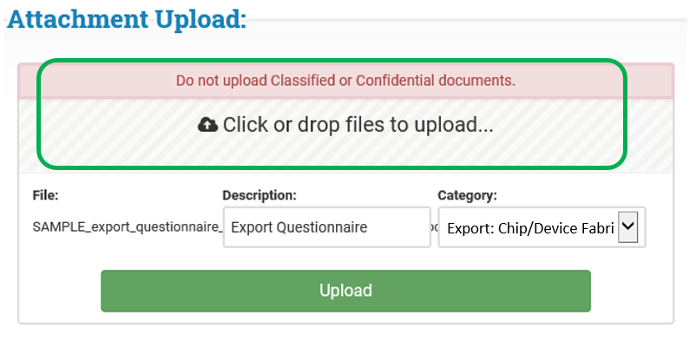**Attachment upload (REQUIRED):**

1. Upload the Export Questionnaire by Clicking or Dropping the file in the area identified with a green box (left).

(*see* *Completing Export Questionnaire* *within this document for details*).

1. Enter a description
2. Select a category
3. Click Upload

Once submitted, the ORIA Export team will be notified and will assign the file for export review.

*Return to Index*

1. **Checking the Status via the Export Control Module in eRouting:**

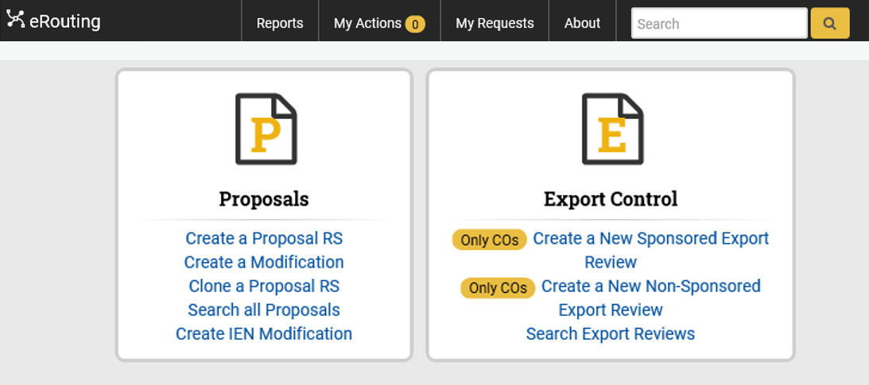

You can check the status of your Export Reviews at by clicking on “My Request” (green box) or by searching for the Export request number (provided by auto email upon submitting the request).

Click on the Export ID (E####) to open your export review.

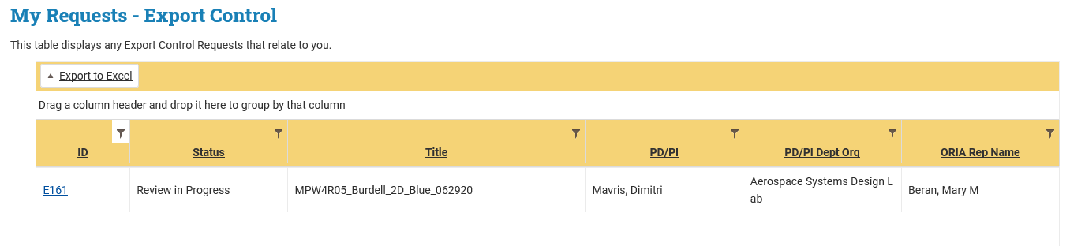

Georgia Tech Research Corporation

Burdell, George P.

The status is available in the status bar at the top of the page.



More details on how to use the eRouting Export module are available in the [User Guide for Export Control eRouting Module](https://oria.gatech.edu/sites/default/files/documents/user_guide_export_control_erouting_module.pdf).

*Return to Index*

1. Glossary

Device ID – name of device submission to foundry. Often referred to as Tile.

MPW – Multi Project Wafer

PI – Principal Investigator

PD – Project Director

*Return to Index*

.045 – RF and MMIC communication

Device to Design – 1 to many?

A “Device” is a set amount of space so you may have 1 design on a Device ID or you may have many designs on a Device ID.

MPW

4R